Name: Saad
Roll no: 076
Section: BSAI-3B
Subject: AI-Lab
Lab task : 4
Task 1:
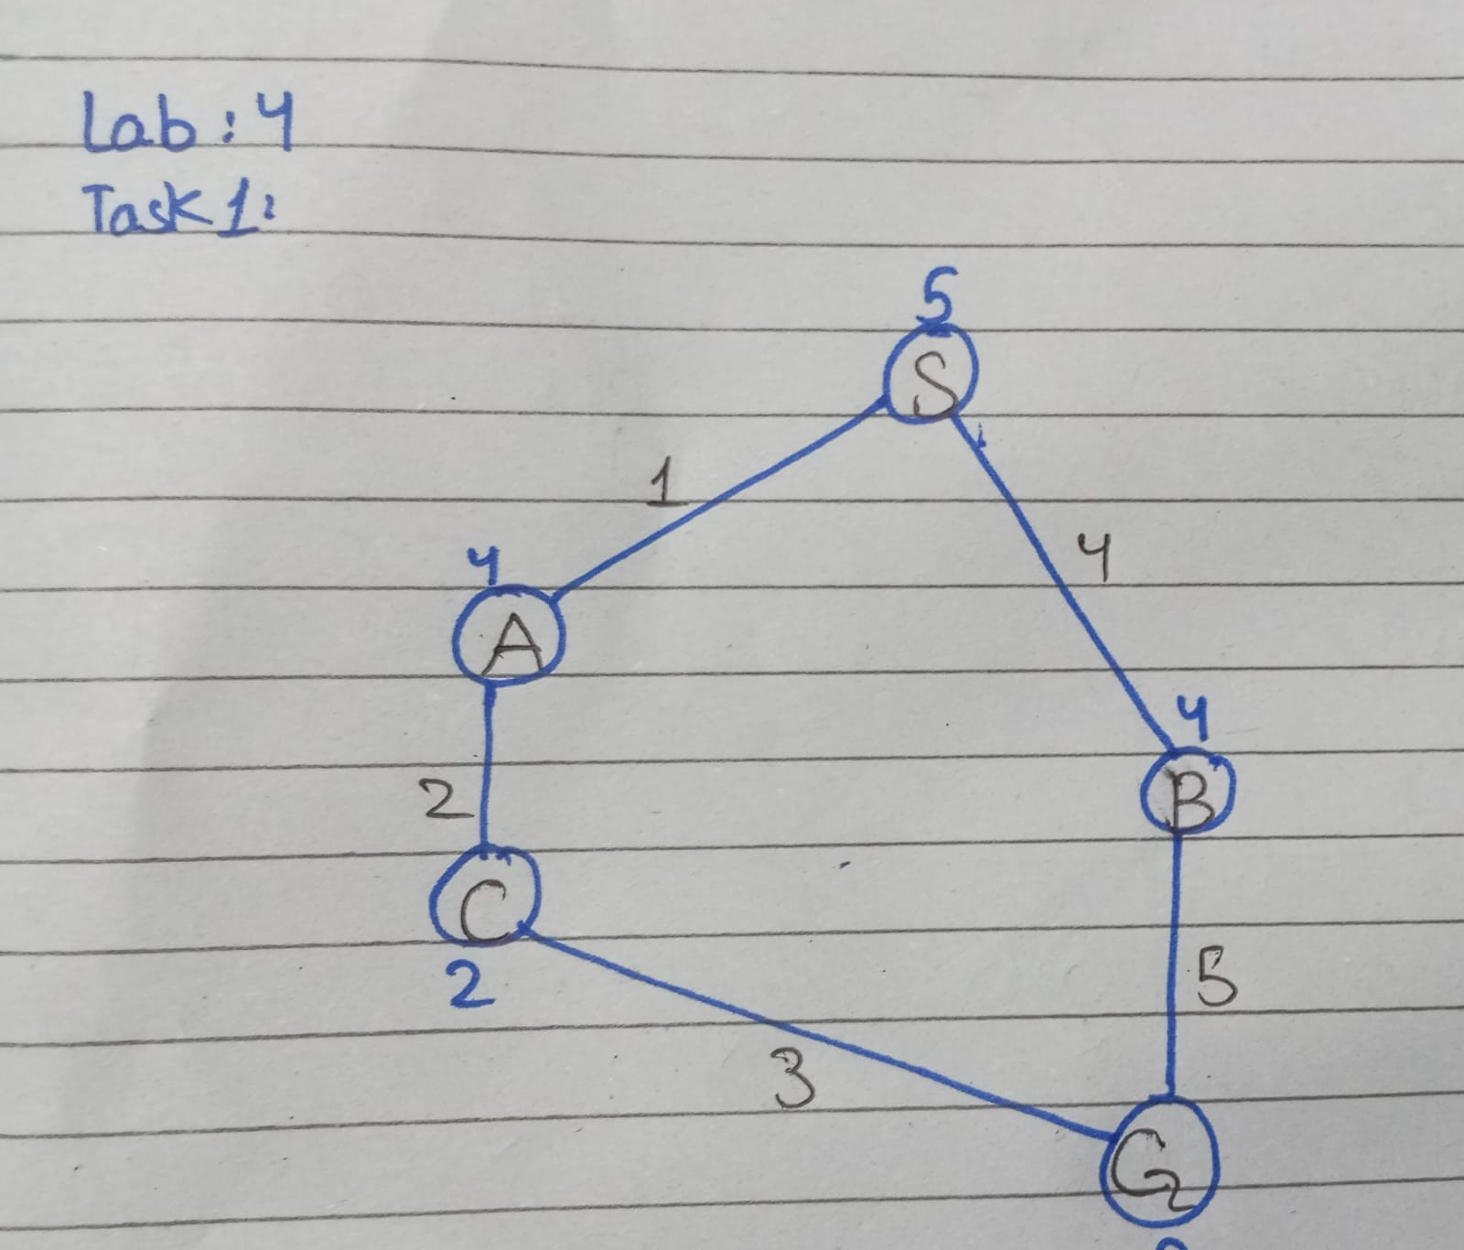
- Step 1 calls astar(g, h, 'S', 'G') to return (6, ['S', 'A', 'C', 'G']) and runs trace(g, h, 'S', 'G'), which pops start node S from pq with g=0, h=5, and f=0+5=5, appends ('S', 0, 5, 5) to exp, pushes neighbors A(f=5, g=1) and B(f=8, g=4), and prints Exp 1 ('S', 0, 5, 5) Frontier: [(5, 1, 'A', ['S', 'A']), (8, 4, 'B', ['S', 'B'])].
- Step 2 pops A from pq ahead of B because f(A)=5 < f(B)=8, appends ('A', 1, 4, 5) to exp, computes ng=1+2=3 and f=3+2=5 for neighbor C, and prints Exp 2 ('A', 1, 4, 5) Frontier: [(5, 3, 'C', ['S', 'A', 'C']), (8, 4, 'B', ['S', 'B'])].
- Step 3 pops C from pq with g=3, h=2, and f=5, appends ('C', 3, 2, 5) to exp, pushes goal G with ng=3+3=6 and f=6+0=6, and prints Exp 3 ('C', 3, 2, 5) Frontier: [(6, 6, 'G', ['S', 'A', 'C', 'G']), (8, 4, 'B', ['S', 'B'])].
- Step 4 audits admissibility against true remaining costs across all five nodes in g and h: h['S']=5<=6, h['A']=4<=5, h['B']=4<=5, h['C']=2<=3, and h['G']=0<=0.
- Step 5 verifies consistency h[u]<=w+h[v] across every directed edge in g: S to A gives 5<=1+4, S to B gives 5<=4+4, A to C gives 4<=2+2, B to G gives 4<=5+0, and C to G gives 2<=3+0, so G(6, 6, 'G', ['S', 'A', 'C', 'G']) is popped next ahead of B(8, 4, 'B', ['S', 'B']).
Output:
Exp 1 ('S', 0, 5, 5) Frontier: [(5, 1, 'A', ['S', 'A']), (8, 4, 'B', ['S', 'B'])]
Exp 2 ('A', 1, 4, 5) Frontier: [(5, 3, 'C', ['S', 'A', 'C']), (8, 4, 'B', ['S', 'B'])]
Exp 3 ('C', 3, 2, 5) Frontier: [(6, 6, 'G', ['S', 'A', 'C', 'G']), (8, 4, 'B', ['S', 'B'])]

Task 2:
- Step 1 executes trace(g, h, 'S', 'G') for A* and trace(g, {k:0 for k in h}, 'S', 'G') for the zero-heuristic UCS control run on the exact same graph g from S to G.
- Step 2 verifies the returned path ['S', 'A', 'C', 'G'] using cost=sum(dict(graph[path[i]])[path[i+1]] for i in range(len(path)-1)), which sums 1+2+3=6 to match g=6 in both runs while holding graph topology, endpoints, and heapq tie-breaking fixed.
- Step 3 logs the A* trace output A*: (6, ['S', 'A', 'C', 'G'], 6, [('S', 0, 5, 5), ('A', 1, 4, 5), ('C', 3, 2, 5)], 3), recording exp=[('S', 0, 5, 5), ('A', 1, 4, 5), ('C', 3, 2, 5)] and len(exp)=3.
- Step 4 prints the first three UCS expansions Exp 1 ('S', 0, 0, 0), Exp 2 ('A', 1, 0, 1), and Exp 3 ('C', 3, 0, 3), and logs UCS: (6, ['S', 'A', 'C', 'G'], 6, [('S', 0, 0, 0), ('A', 1, 0, 1), ('C', 3, 0, 3), ('B', 4, 0, 4)], 4), where expanding B increases len(exp) from 3 to 4.
- Step 5 enforces the expansion counting rule by checking if node==goal: return g, path, cost, exp, len(exp) before exp.append((node, g, h[node], f)), so popping G terminates the search and excludes goal processing from len(exp).
- Step 6 applies the guard condition if g!=best[node]: continue together with if ng<best.get(nxt,float('inf')) to skip stale priority-queue entries whenever a cheaper path to a state is recorded in best.

Output:
A*: (6, ['S', 'A', 'C', 'G'], 6, [('S', 0, 5, 5), ('A', 1, 4, 5), ('C', 3, 2, 5)], 3)
Exp 1 ('S', 0, 0, 0) Frontier: [(1, 1, 'A', ['S', 'A']), (4, 4, 'B', ['S', 'B'])]
Exp 2 ('A', 1, 0, 1) Frontier: [(3, 3, 'C', ['S', 'A', 'C']), (4, 4, 'B', ['S', 'B'])]
Exp 3 ('C', 3, 0, 3) Frontier: [(4, 4, 'B', ['S', 'B']), (6, 6, 'G', ['S', 'A', 'C', 'G'])]
UCS: (6, ['S', 'A', 'C', 'G'], 6, [('S', 0, 0, 0), ('A', 1, 0, 1), ('C', 3, 0, 3), ('B', 4, 0, 4)], 4)

Task 3:
- Step 1 executes h['C']=10 to overwrite the original heuristic value h['C']=2, which deliberately violates admissibility because the true remaining cost from C to G is 3.
- Step 2 expands ('S', 0, 5, 5) at Exp 1 and ('A', 1, 4, 5) at Exp 2, pushing C onto pq with ng=3 and ng+h['C']=3+10=13 so Exp 2 prints Frontier: [(8, 4, 'B', ['S', 'B']), (13, 3, 'C', ['S', 'A', 'C'])].
- Step 3 pops and expands ('B', 4, 4, 8) at Exp 3 because f(B)=8 is less than f(C)=13, pushing goal G via B with ng=4+5=9 and f=9+0=9 to produce Frontier: [(9, 9, 'G', ['S', 'B', 'G']), (13, 3, 'C', ['S', 'A', 'C'])].
- Step 4 pops G with g=9 ahead of (13, 3, 'C', ['S', 'A', 'C']), printing Overestimate: (9, ['S', 'B', 'G']) (9, ['S', 'B', 'G'], 9, [('S', 0, 5, 5), ('A', 1, 4, 5), ('B', 4, 4, 8)], 3) with verified cost 9, exp=[('S', 0, 5, 5), ('A', 1, 4, 5), ('B', 4, 4, 8)], and len(exp)=3.
- Step 5 demonstrates how setting h['C']=10 removes the optimality guarantee of graph-search A* by inflating C's f-value above the total cost of the suboptimal route through B.
- Step 6 shows that even if a smaller overestimate kept the returned path unchanged on this graph, A* loses its optimality guarantee because if node==goal returns as soon as G is popped before higher-f frontier nodes are expanded.
Output:
Exp 1 ('S', 0, 5, 5) Frontier: [(5, 1, 'A', ['S', 'A']), (8, 4, 'B', ['S', 'B'])]
Exp 2 ('A', 1, 4, 5) Frontier: [(8, 4, 'B', ['S', 'B']), (13, 3, 'C', ['S', 'A', 'C'])]
Exp 3 ('B', 4, 4, 8) Frontier: [(9, 9, 'G', ['S', 'B', 'G']), (13, 3, 'C', ['S', 'A', 'C'])]
Overestimate: (9, ['S', 'B', 'G']) (9, ['S', 'B', 'G'], 9, [('S', 0, 5, 5), ('A', 1, 4, 5), ('B', 4, 4, 8)], 3)

Edge Cases:
Setting h['C']=10 inflates C to (13, 3, 'C', ['S', 'A', 'C']) behind (8, 4, 'B', ['S', 'B']) and (9, 9, 'G', ['S', 'B', 'G']) so astar and trace return (9, ['S', 'B', 'G']), while g!=best[node] skips stale heap entries, start==goal ('S' to 'S') returns g=0 with len(exp)=0, and mixing metres with travel-time units skews ng+h[nxt].

Limitations:
astar and trace store all active pq tuples and best dictionary costs in memory, lose optimality when h[nxt] overestimates true remaining cost, require h values to match edge-weight units in g, and incur heapq push/pop overhead on small graphs.

Reflection:
Implementing astar(g, h, 'S', 'G') and trace(g, h, 'S', 'G') showed how admissible heuristics prune B (len(exp)=3 vs 4 in zero-heuristic UCS) while h['C']=10 returned the cost-9 path ['S', 'B', 'G'], so next time I will add an automated admissibility and consistency check before running A*.

